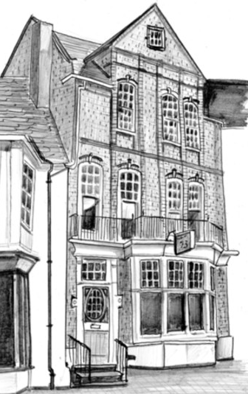
THE MANNA HOUSE COUNSELLING SERVICE
73 St Giles Street,
Northampton NN1 1JF

Diploma in Christian Counselling
LEVEL 4 - COURSE APPLICATION
Papers related to this selection process are held confidentially and destroyed when no longer needed.

Personal Details (block capitals please)
Surname: | First Name: | Title:
Address:  Postcode: | Date of Birth:
 | Home Phone Nº :
 | Mobile Phone Nº:
 | Email:
Occupation | Part Time:  Full Time:
Where did you hear about this course?

How did you become interested in counselling?

Experience/Training

Please state all educational training or experience relevant to counselling, for example – Level 2 and 3 Counselling Courses:

Please give details of all caring, support or pastoral experience you have had or led:

Please give details of your highest educational qualification/s – GCSE/A’level/degree:
Qualification: | Training Establishment: | Date taken: | Level obtained:
eg: A’level Biology | Southmoor Academy | June 2016 | Grade

Church Involvement

Outline briefly how and when you became a Christian and identify the effect this had on your life:

Name of Church, (if appropriate), and number of years you have been a member?

Is your minister aware that you have applied for this course?

How are you involved in your church at present?

Our Level 4 Diploma in Christian Counselling requires students to be increasingly self aware and therefore may make demands on students emotional and mental state, please give details of family and friends who can support and encourage you:

Additional Information

Have you had personal experience of counselling in the past? Yes No

If Yes, have you had counselling within the last 6 months? Yes No
Do you have any specific requirements that we should be aware of, for example, physical disability or learning needs? If so please give brief details:

Please give further details of any physcial or mental health issues and diagnosis including any medication/s:

Do you have any criminal/legal convictions or are you on the sex offenders register?

Yes No
If you answered Yes please give details:

Please use this section to write a pre course essay.
Having completed some recognised training in counselling and come to the point of wanting to do the Diploma course, what have you learnt about yourself so far? How has it changed you and what impact has it had on others? Finally, how does this shape what you feel you bring to the counselling process and the profession as a whole?
This should be approx. 1300 – 1700 words.

Please continue on a separate sheet of paper as necessary ….

References

Please give the name of two people who are willing to provide a reference for you. Your referees must not be a relative and should have known you personally for some time. At least one should be your minister or a church leader:
(If in the last 12 months, you have completed a Level 3 course with Manna House, one further referee from your church leadership will be sufficient)

Referee 1:
Surname: | First Name: | Title:
Email:

Address (+postcode) if email not provided:

Referee 2:
Surname: | First Name: | Title:
Email:

Address (+ postcode) if email not provided:

Declaration

Please sign below to verify, to the best of your knowledge, that all the information you have provided is accurate. By signing you also give us permission to keep your data on file and to forward it to the Counselling and Psychotherapy Central Awarding Body (CPCAB) for registration purposes (GDPR compliance).
Signed: | Date:

I declare that should I be offered and accept a place on this course, I am committing to pay for all training received.
Signed: | Date:

Deposit (Non-refundable)
Deposits can be paid either by cheque made payable to - Manna House Trust, or electronically by bank transfer to:
Manna House Trust, Co-operative Bank PLC
A/C 50136872 Sort Code 08-90-73.
Please reference your bank transfer using your name and course level (e.g. J Bloggs – L4) or write this information on the back of your cheque.

I enclose a cheque for £250 I have paid £250 by bank transfer

When completed, this form should be returned along with £250 non-refundable deposit to:

Training Administrator
Training@mannahouse.org.uk or
The Manna House Counselling Service,
73 St Giles Street,
Northampton NN1 1JF

Places are limited so please return your application as soon as possible.

