**The Manna House Counselling Service**

73 St Giles Street

Northampton NN1 1JF

**Tel:** 01604 633304

**E-mail:** training@mannahouse.org.uk

**Web:** www.mannahouse.org.uk



**APPLICATION FORM**

Level 3 Certificate in Christian Counselling

*Papers related to this selection process are held confidentially and destroyed when no longer needed.*

|  |  |  |
| --- | --- | --- |
| Personal Details (block capitals please) | | |
| Surname: | First Name: | Title: |
| Address:  Postcode: | Preferred Name: | |
| Home Phone No : | |
| Mobile Phone No: | |
| Email: | |
| Occupation: | | |
| Where did you hear about this course? | | |
| How did you become interested in counselling? | | |

|  |
| --- |
| Experience/Training |
| Please give details of professional, educational and counselling qualifications including grades |
| Please give details of all caring, support or pastoral experience you have had or led: |

|  |
| --- |
| Church Involvement |
| Outline briefly how and when you became a Christian and identify the effect this had on your life. |
| Name of Church, (if appropriate), and number of years you have been a member? |
| Is your minister aware that you have applied for this course? |
| How are you involved in your church at present? |
| Our Level 3 Counselling course requires students to be increasingly self aware and therefore may make demands on students emotional and mental state, please give details of family and friends who can support and encourage you: |

|  |
| --- |
| Additional Information |
| Have you had personal experience of counselling in the past? Yes No    If Yes, have you had counselling within the last 6 months? Yes No |
| Do you have any specific requirements that we should be aware of, for example, physical disability or learning needs? If so please give brief details: |
| Please give further details of any physcial or mental health issues and diagnosis including any medication/s: |

|  |
| --- |
| Do you have any criminal/legal convictions or are you on the sex offenders register?  Yes No  If you answered Yes please give details: |

|  |
| --- |
| Pre Course Essay |
| Please write an essay of between 800 – 1,000 words. Reflect on your background, life and Christian experiences showing how these have shaped, motivated and influenced your interest in helping others. *(Continue on a separate sheet if necessary)* |

|  |
| --- |
| References |
| Please give the name of two people who are willing to provide a reference for you. Your referees must not be a relative and should have known you personally for some time. At least one should be your minister or a church leader:  *(If in the last 12 months, you have completed our Level 2 course and provided a referee, one further referee will be sufficient.)* |

|  |  |  |
| --- | --- | --- |
| Referee 1: | | |
| Surname: | First Name: | Title: |
| Email: | | |

|  |  |  |
| --- | --- | --- |
| Referee 2: | | |
| Surname: | First Name: | Title: |
| Email: | | |

|  |  |
| --- | --- |
| Declaration | |
| Please sign below to verify, to the best of your knowledge, that all the information you have provided is accurate. By signing you also give us permission to keep your data on file and to forward it to the Association of Christian Counsellors and CPCAB - Counselling and Psychotherapy Central Awarding Body, for registration purposes (GDPR compliance). | |
| Signed: | Date: |

|  |  |
| --- | --- |
| Please note all courses are run subject to sufficient student uptake. Decisions to run a course are made up to two weeks before the start date. Should a course be cancelled by Manna House then your full deposit and any course fees will be refunded.  I declare that I have read the Terms of Application and, should I be offered and accept a place on this course, I am committing to pay for all training received. | |
| Signed: | Date: |

|  |
| --- |
| Deposit (Non-refundable unless the course is cancelled by Manna House) |
| Deposits can be paid either by cheque made payable to – The Manna House Trust, or electronically by bank transfer to:  The Manna House Trust, Co-operative Bank PLC  A/C **50136872** Sort Code **08-90-73**.  Please reference your bank transfer using your name and course level (e.g. J Bloggs – L3) or write this information on the back of your cheque.  I enclose a cheque for £150 I have paid £150 by bank transfer |

When completed, this form should be returned along with £150 non-refundable deposit to:

Training Administrator

[Training@mannahouse.org.uk](mailto:Training@mannahouse.org.uk) or

The Manna House Counselling Service,

73 St Giles Street,

Northampton NN1 1JF

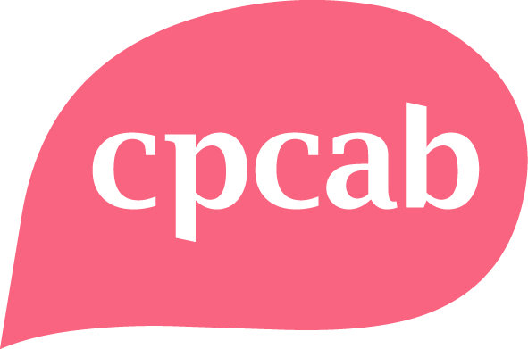

Places are limited so please return your application as soon as possible.

